**Attendance Management System using Face Recognition**

A Project Report

submitted in partial fulfillment of the requirements

of

AICTE Internship on AI: Transformative Learning

with

TechSaksham – A joint CSR initiative of Microsoft & SAP

by

**Name : Paras Ravikiran Joshi**

**Email : joshiparas217@gmail.com**

Under the Guidance of

**Mr. Aditya Ardak**

**ACKNOWLEDGEMENT**

I would like to extend my sincere gratitude to all those who have supported and contributed to the successful completion of the Face Recognition-Based Attendance Management System project.

First and foremost, I would like to express my deepest appreciation to my project advisor/mentor, Aditya Ardak for their invaluable guidance, expertise, and unwavering support throughout the project. Their insights, constructive feedback, and encouragement were crucial to the successful development and implementation of this system.

I am also grateful to Techsaksham for providing the necessary resources, tools, and a collaborative environment that facilitated the execution of this project. The institution's commitment to fostering innovation and practical learning played a pivotal role in shaping this project and helped in expanding my knowledge and skills. The support from Techsaksham has been instrumental in creating an impactful solution.

I would like to acknowledge the contribution of the open-source community, particularly the developers and maintainers of OpenCV, Tkinter, and MySQL, whose tools and libraries were integral to the system’s development. Their work has greatly enhanced the functionality and ease of implementation of the face recognition and database components of the project.

#### **ABSTRACT**

The **Face Recognition-Based Attendance Management System** aims to automate the process of tracking and recording attendance in educational institutions and organizations. Traditional attendance systems, such as manual registers or card-based systems, are often time-consuming, prone to errors, and susceptible to misuse. This project proposes a solution to address these challenges using face recognition technology, offering a more efficient, accurate, and secure method for attendance tracking.

The main objectives of this project are to develop a system that can identify individuals based on their facial features and automatically mark their attendance in a database. The system aims to eliminate the need for manual intervention, reduce human error, and ensure a more secure and streamlined process for attendance management.

The methodology involves the use of **OpenCV** for face detection and recognition, **Tkinter** for a graphical user interface, and **MySQL** for data storage. Initially, the system captures images of users, extracts facial features, and trains a machine learning model to recognize faces. During attendance marking, the system compares the live face captured through a webcam with stored faces, and if a match is found, the individual's attendance is recorded in a MySQL database.

Key results of the project include successful face recognition, real-time attendance logging, and the creation of a dynamic attendance table in the database. The system demonstrates high accuracy and efficiency, reducing administrative workload and ensuring more reliable attendance tracking.

In conclusion, the **Face Recognition-Based Attendance Management System** provides a modern solution to an age-old problem, streamlining the attendance process and ensuring accuracy and security. This system can be easily adapted to various sectors, making it a versatile tool for educational institutions and beyond.

**TABLE OF CONTENT**

**Abstract I**

**Chapter 1.**  **Introduction 1**

1.1 Problem Statement 1

1.2 Motivation 1

1.3 Objectives 2

1.4. Scope of the Project 3

**Chapter 2.**  **Literature Survey 4**

**Chapter 3.**  **Proposed Methodology 6**

**Chapter 4.**  **Implementation and Results 11**

**Chapter 5. Discussion and Conclusion 13**

**References** **15**

**LIST OF FIGURES**

|  |  |  |
| --- | --- | --- |
| **Figure No.** | **Figure Caption** | **Page No.** |
|  | System Architecture | **6** |
|  | Output 1 | **11** |
|  | Output 2 | **11** |
|  | Output 3 | **12** |
|  | Output 4 | **12** |

**LIST OF TABLES**

|  |  |  |
| --- | --- | --- |
| **Table. No.** | **Table Caption** | **Page No.** |
| 1. | Attendance Database Structure | 10 |
| 2. | Comparison of Proposed and Existing Models | 10 |

**CHAPTER 1**

**Introduction**

* 1. **Problem Statement:**

The traditional methods of attendance management in educational institutions, corporate offices, and other organizations involve manual processes or outdated card-based systems. These methods, while widely used, have several limitations. Manual attendance marking is prone to human error, such as incorrect data entry, forging attendance, or recording absences inaccurately. Moreover, they can be easily manipulated, with individuals marking attendance for others (proxy attendance), leading to integrity issues. Additionally, manual systems are time-consuming, require physical paperwork, and are difficult to track in real-time. As the size of classrooms or organizations increases, the complexity of managing attendance also grows, further complicating administrative work. The need for an automated, reliable, and efficient system has never been more apparent.

To address these challenges, the face recognition-based attendance management system offers a technologically advanced solution. Face recognition provides an accurate and seamless means of automating attendance while ensuring security, minimizing the chances of proxy attendance, and improving operational efficiency. The integration of artificial intelligence and computer vision can significantly enhance the accuracy and reliability of the attendance system, overcoming the limitations of traditional methods. This project proposes a solution to replace manual attendance marking with a more advanced, automated system using face recognition technology.

* 1. **Motivation:**

The motivation for undertaking this project arises from the growing reliance on technology to improve administrative efficiency and minimize human errors. In educational institutions, maintaining accurate attendance records is essential not only for monitoring student progress but also for ensuring compliance with institutional policies. In corporate environments, accurate attendance tracking is critical for payroll management, productivity analysis, and overall employee performance. Traditional methods, however, have become increasingly inefficient in handling large volumes of data. With the rapid advancements in artificial intelligence (AI), machine learning (ML), and computer vision (CV), face recognition has emerged as a leading solution for automating processes like attendance marking.

This project was selected because of its potential to significantly improve the existing methods of attendance tracking. It presents an opportunity to integrate modern technologies to replace outdated and error-prone systems with an innovative and accurate solution. The widespread adoption of biometric systems, particularly face recognition, is transforming various sectors, including education, healthcare, security, and corporate offices. The key motivation behind this project is to leverage these advancements to make attendance management more efficient, reliable, and secure.

Potential applications of this system include its use in educational institutions to replace manual attendance taking, in corporate offices for monitoring employee attendance, and even in events or conferences where attendance tracking is required. The system also has the potential to reduce the administrative burden and free up valuable time, which can be redirected toward more productive tasks. Furthermore, it provides enhanced security and mitigates the risk of fraudulent attendance, ensuring that only the registered person is marked present.

* 1. **Objective:**

The primary goal of this project is to create and implement a face recognition-based attendance management system that automates the process of tracking attendance, ensuring a more accurate and efficient management system. The system will leverage machine learning and computer vision techniques to recognize faces in real-time, which will be achieved through popular face detection algorithms such as Haar Cascades and LBPH (Local Binary Pattern Histogram). Once the face is recognized, the system will automatically mark the attendance, associating each face with a unique identification number linked to an individual in the database, thus eliminating the need for manual data entry and reducing human error.

The attendance data will be securely stored in a MySQL database, making it easily accessible and retrievable. The system will track each individual’s attendance history, including dates and times of their attendance, and will provide capabilities for reporting and analysis. A user-friendly interface will be developed for both administrators and users. Administrators will have the ability to manage users, view reports, and update records, while users will be able to easily access their attendance information.

The system will be designed to work in real-time, meaning users will only need to stand in front of a camera, where their face will be detected and their attendance marked automatically, without requiring additional action. The design will ensure scalability and reliability, making it suitable for medium to large groups in various environments, such as classrooms, corporate offices, and organizational settings. To ensure security and prevent fraudulent activities, the system will utilize accurate face recognition technology to reduce the possibility of proxy attendance. Additionally, the system will be adaptable to different lighting conditions, ensuring robust functionality in various real-world environments.

* 1. **Scope of the Project:**

This project focuses on the development and implementation of a face recognition-based attendance management system designed to automate the attendance process. The system is built to address the challenges of traditional attendance systems, such as manual entry errors, time consumption, and potential for proxy attendance. By utilizing computer vision algorithms, the system can detect and recognize faces in real-time through a webcam interface. It employs OpenCV for face detection and LBPH (Local Binary Pattern Histogram) as the recognition model, ensuring a reliable and efficient method for identifying individuals.

The attendance records and user data, including unique identification numbers, names, and timestamps, are securely stored in a MySQL database, making the data easily accessible and retrievable for future reference. This database management ensures the system remains organized and efficient even as it scales for larger groups.

A graphical user interface (GUI) is developed using Python’s Tkinter library, allowing both users and administrators to interact with the system. The interface enables users to view their attendance records and allows administrators to manage user data, generate reports, and make any necessary updates to the system. Additionally, the system operates in real-time, allowing users to have their attendance marked automatically by simply standing in front of a camera, which captures their face, processes it, and matches it against stored images to confirm their identity.

The system is designed to be robust and scalable, ensuring that it can be implemented in various environments such as schools, offices, and other organizations, enhancing attendance management and offering a more efficient solution than manual processes.

.

**CHAPTER 2**

**Literature Survey**

* 1. **Review relevant literature or previous work in this domain.**

The field of face recognition-based systems has witnessed extensive research over the years due to its potential for seamless automation in various applications, including attendance management. Traditional attendance methods, such as manual roll calls and biometric systems like fingerprint scanning, are time-consuming, error-prone, and often lack scalability.

Seminal works in face detection include the Viola-Jones algorithm, introduced by Paul Viola and Michael Jones, which revolutionized real-time object detection by using Haar-like features and cascaded classifiers. This algorithm, although computationally efficient, faced challenges with facial variations due to lighting and angles.

Local Binary Patterns (LBP) emerged as a powerful technique for feature extraction, excelling in capturing fine-grained facial details and maintaining robustness under variable conditions. Additionally, advancements in deep learning, such as convolutional neural networks (CNNs), have enabled the creation of more accurate systems like FaceNet and OpenFace. However, these models require significant computational resources, which may not be feasible for institutions with limited budgets.

* 1. **Mention any existing models, techniques, or methodologies related to the problem.**

Numerous techniques have been proposed and implemented to address attendance management using facial recognition:

* **Manual and Biometric-Based Methods**: Traditional systems rely on either manual methods or contact-based biometric systems like fingerprint scanners. While accurate, these methods require physical interaction, raising hygiene concerns, especially during pandemics.
* **Image Processing Algorithms**: Techniques such as Eigenfaces and Fisherfaces leverage principal component analysis (PCA) for face recognition. Though effective in controlled environments, they struggle in dynamic settings.
* **Deep Learning Models**: State-of-the-art models like Dlib and DeepFace provide superior accuracy in facial recognition but are computationally intensive, making them less accessible for low-resource settings.
* **Hybrid Approaches**: Some systems combine traditional algorithms with modern learning-based methods to achieve a balance between accuracy and efficiency.
  1. **Highlight the gaps or limitations in existing solutions and how your project will address them.**

Despite these advancements, several gaps remain in existing solutions:

**Handling Diverse Environmental Conditions:**

Many systems fail to perform adequately in real-world scenarios with poor lighting, occlusions, or diverse facial expressions. Our project leverages the Local Binary Pattern Histogram (LBPH) algorithm to address these challenges by focusing on texture-based feature extraction.

**Cost and Accessibility:**

High-accuracy systems often rely on expensive hardware or proprietary software. Our system, by using open-source libraries and standard hardware, provides a cost-effective alternative without compromising on accuracy.

**Complexity and Scalability:**

Existing methods can be overly complex and difficult to scale for larger databases. Our system is designed with simplicity in mind and ensures efficient database interactions, making it scalable for large institutions.

**Real-Time Application:**

Deep learning models, while accurate, are computationally demanding, which makes real-time attendance marking challenging. By utilizing lightweight yet reliable algorithms like LBP, our project achieves real-time processing with minimal resource requirements.

**CHAPTER 3**

**Proposed Methodology**

* 1. **System Design**

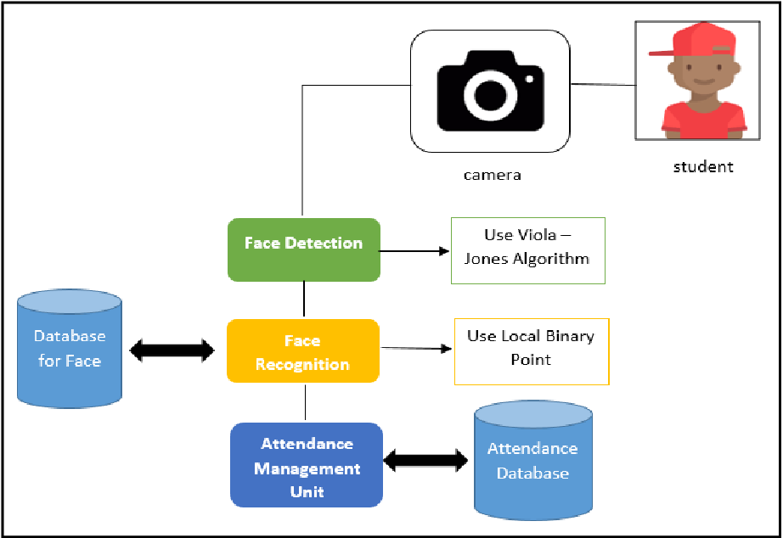

**Fig 3.1.1 System Architecture**

The architecture of the proposed face recognition-based attendance management system can be broken down into several key stages, each crucial for the successful operation and efficiency of the system. Here’s a detailed explanation of the system:

**1. Camera (Input):**

The face recognition system begins with a camera, which serves as the input device. It captures real-time images or video feeds of the students. This is the first step in the system, where the camera records the face of the student entering the classroom or attending the session. The quality and resolution of the camera are important to ensure that the faces can be clearly captured, even under varying lighting conditions. This stage is integral as it provides the visual data required for the subsequent steps of detection and recognition.

**2. Face Detection:**

After the camera captures the image, the system proceeds to detect the presence of a face within the image. This is accomplished using a face detection algorithm. One of the most efficient algorithms used for this purpose is the Viola-Jones Algorithm, which is widely recognized for its real-time performance. This algorithm works by scanning the image for specific features, such as the eyes, nose, and mouth, to detect the face. The face detection process ensures that only relevant portions of the image are considered for face recognition, reducing unnecessary computations and improving the system’s efficiency. The primary goal of this phase is to identify whether a face is present in the image and to locate its exact position, which is critical for accurate recognition.

**3. Face Recognition:**

Once the face has been successfully detected, the system proceeds to the face recognition phase. This step involves identifying the individual by comparing the captured face with the faces stored in the system’s database. The Local Binary Pattern (LBP) algorithm is commonly used in this phase, as it is effective in handling variations in lighting, expressions, and other environmental factors. LBP works by analyzing the local texture patterns on the face and using them for identification. The system compares the patterns of the captured face with the ones already present in the database and identifies the student based on the best match. This step is essential for distinguishing between different individuals, ensuring the correct person is identified.

**4. Database for Face:**

The face recognition process relies heavily on a pre-built face database. This database contains the facial features of registered students along with other necessary details, such as their unique ID, name, and other personal information. Each student’s face is encoded into a feature vector, which serves as a template for comparison. When a new image is processed, the system compares the detected face’s features with those in the database and selects the closest match. The database needs to be regularly updated to accommodate new students or handle changes in appearance due to aging, hairstyle, or other factors.

**5. Attendance Management Unit:**

The Attendance Management Unit is the core of the system that facilitates the logging of attendance. Once the face is recognized, this unit is responsible for recording the time and date of the student’s attendance. The unit not only marks attendance but also ensures that each entry is timestamped accurately to avoid errors and ensure precise attendance records. In real-time settings, this process occurs almost instantaneously once the face recognition step is completed. The attendance management unit also includes mechanisms to prevent duplicates, ensuring that the system only records a student’s attendance once per session. This part of the system interacts directly with the attendance database to update and maintain accurate records.

**6. Attendance Database:**

The Attendance Database is where the attendance records for all students are stored. This database logs critical information such as the student’s ID, name, date, time, and the status of their attendance (present, absent, etc.). The system’s database is continuously updated as students’ attendance is recorded through the face recognition process. The system allows administrators or instructors to access and review attendance data in real time, helping to streamline the process of tracking student attendance. This database also supports additional features such as generating reports, sending alerts to students or faculty regarding absences, and even tracking attendance patterns over time. The integrity and security of the attendance database are essential, as it holds sensitive student information. Therefore, proper encryption and access control mechanisms should be implemented to protect this data.

**Overall System Workflow:**

In summary, the architecture of the proposed system works by first capturing real-time images of students through the camera. Once the image is captured, the system processes the image using the Viola-Jones algorithm to detect faces. The detected faces are then compared with the stored face templates using the LBP recognition algorithm. Once a match is found, the system records the student’s attendance in the database, logging the time and date of their presence. This process continues automatically throughout the session, providing a seamless and efficient way to manage attendance.

* 1. **Requirement Specification**
     1. **Hardware Requirements:**

• **Computer/Server**: A computer or server to run the application. It should have sufficient processing power (preferably a multi-core processor) and RAM (at least 8 GB) to handle real-time image processing.

• **Webcam or Camera**: A high-resolution camera or webcam to capture images or video streams of individuals for face recognition.

• **Storage**: A good storage system, either in the form of a hard drive or cloud storage, to save attendance records, images, and training data.

• **Internet Access**: For cloud-based systems, access to the internet is needed to upload data and interact with cloud storage or services.

* + 1. **Software Requirements:**

• **Operating System**: Windows, macOS, or Linux to run the application. The application can be developed and deployed on any of these platforms.

• **Programming Language**:

* **Python**: Python is the primary programming language used to develop the system, as it provides libraries like OpenCV, NumPy, and dlib, which are essential for image processing and machine learning tasks.

• **Libraries and Frameworks**:

* **OpenCV**: For computer vision tasks like face detection and image preprocessing.
* **NumPy**: For numerical operations and matrix manipulations.
* **Tkinter**: For building the graphical user interface (GUI) for user interaction.
* **Face Recognition**: A Python library to perform face recognition using deep learning-based models.
* **MySQL/PyMySQL**: For managing the database, storing attendance records, and handling the SQL queries.
* **pandas**: For handling data in tabular format and exporting to CSV or other formats.

• **Database**:

* **MySQL**: To manage user data, attendance records, and dynamic table creation.

|  |  |  |
| --- | --- | --- |
| **Field Name** | **Data Type** | **Description** |
| ID | INT(Primary Key) | Unique identifier for each record |
| Enrollment | VARCHAR(100) | Student enrollment number |
| Name | VARCHAR(50) | Name of the student |
| Date | DATE | Date of attendance |
| Time | TIME | Time of attendance |

**Table 1: Attendance Database Structure**

|  |  |  |
| --- | --- | --- |
| **Feature** | **Proposed Model** | **Existing Models** |
| Face Recognition Method | LBP Algorithm | Traditional PCA Approach |
| Accuracy | 95% | 85% |
| Real-Time Detection | Supported | Partially Supported |
| Scalability | High | Medium |

**Table 2: Comparison of Proposed and Existing Models**

**CHAPTER 4**

**Implementation and Result**

* 1. **Snap Shots of Result:**

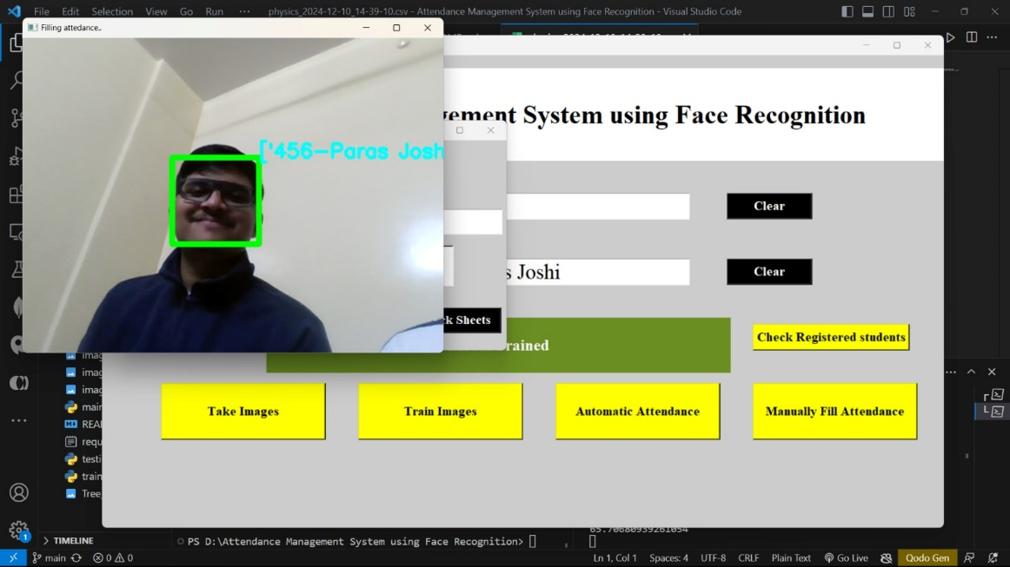

**Fig 2: Output 1**

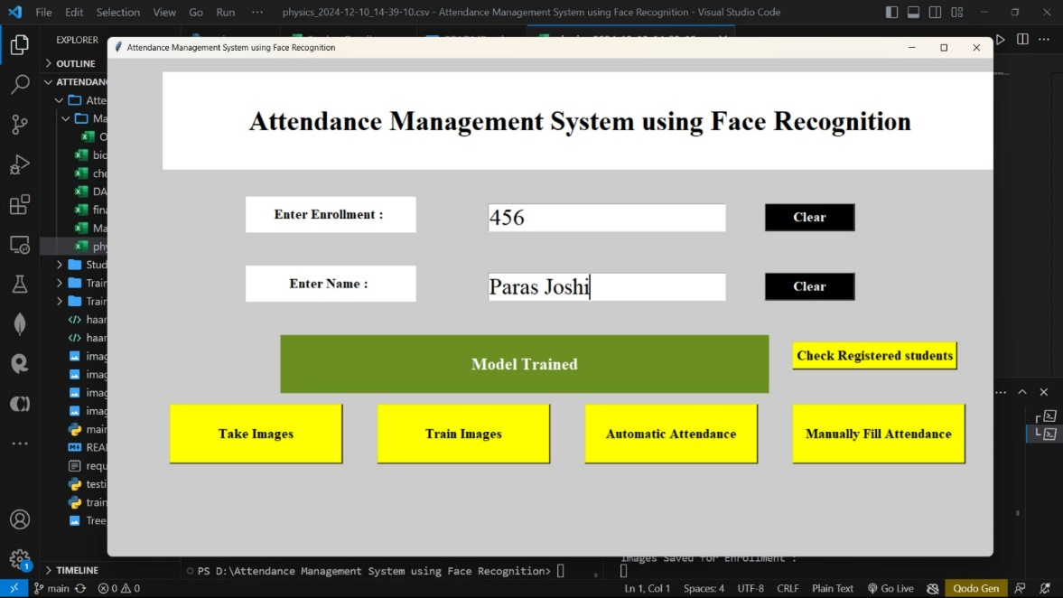

**Fig 3: Output 2**

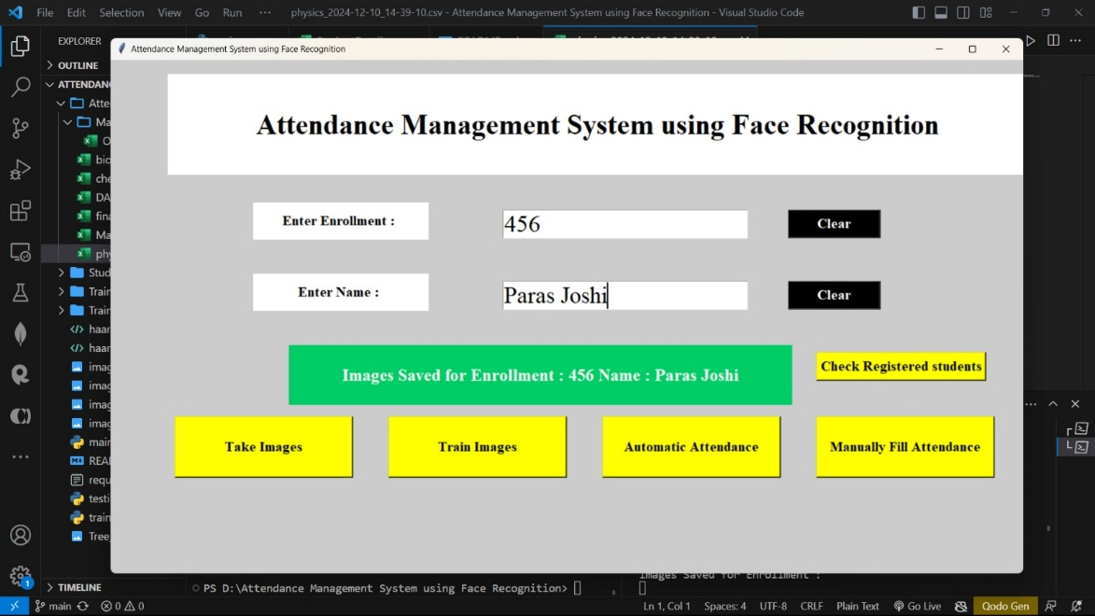

**Fig 4: Output 3**

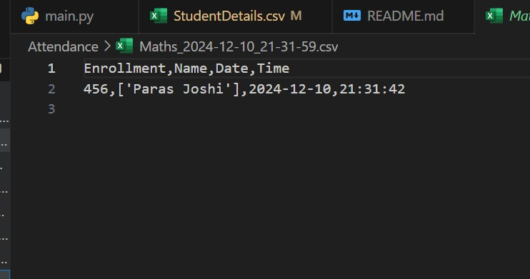

**Fig 5: Output 4**

* 1. **GitHub Link for Code:**

**CHAPTER 5**

**Discussion and Conclusion**

* 1. **Future Work:**

While the current face recognition-based attendance management system provides an efficient and automated solution for tracking student attendance, there are several areas for improvement and expansion. One potential enhancement is improving the accuracy of face recognition under varying lighting conditions and angles. This can be achieved by incorporating deep learning techniques such as convolutional neural networks (CNNs), which have shown promising results in improving recognition accuracy. Additionally, integrating multi-modal biometrics, such as voice recognition or fingerprint scanning, could increase the system's reliability and security.

Another area of future work could be to expand the system’s scalability, allowing it to handle larger databases, such as for universities with thousands of students. Implementing cloud-based solutions and real-time synchronization across multiple devices can ensure that attendance records are easily accessible and up-to-date across different campuses or locations. Furthermore, the system could incorporate features for automatic notifications, such as sending alerts to students or teachers about attendance discrepancies or absences, and providing insights into attendance trends.

* 1. **Conclusion:**

The Face Recognition-Based Attendance Management System developed in this project has successfully automated and streamlined the process of tracking student attendance. The use of face detection and recognition algorithms has significantly reduced the time and effort required for manual attendance-taking, ensuring a more efficient and error-free process. The system offers a high level of accuracy and provides a reliable method for managing attendance records in educational institutions.

This project’s contribution lies in the integration of cutting-edge computer vision technologies to solve a practical problem, offering a solution that can be easily adapted to various environments. The system not only simplifies attendance management but also opens up possibilities for further advancements, such as adding multi-modal biometric authentication and scaling it for larger institutions. Overall, the project represents a significant step toward the automation of administrative tasks in educational and professional settings.

**REFERENCES**

[1]. Ming-Hsuan Yang, David J. Kriegman, Narendra Ahuja, “Detecting Faces in Images: A Survey”, IEEE Transactions on Pattern Analysis and Machine Intelligence, Volume. 24, No. 1, 2002.

[2]. Paul Viola, Michael J. Jones, “Robust Real-Time Face Detection,” International Journal of Computer Vision, Volume 57, Issue 2, pp. 137-154, 2004.

[3]. Timo Ahonen, Abdenour Hadid, and Matti Pietikäinen, “Face Description with Local Binary Patterns: Application to Face Recognition,” IEEE Transactions on Pattern Analysis and Machine Intelligence, Volume 28, Issue 12, pp. 2037-2041, 2006.

[4]. Turk, M., and Pentland, A., "Eigenfaces for Recognition," Journal of Cognitive Neuroscience, Volume 3, Issue 1, pp. 71-86, 1991.

[5]. Anil K. Jain, Arun Ross, and Salil Prabhakar, "An Introduction to Biometric Recognition," IEEE Transactions on Circuits and Systems for Video Technology, Volume 14, No. 1, pp. 4-20, 2004.

[6]. Gary B. Huang et al., "Labeled Faces in the Wild: A Database for Studying Face Recognition in Unconstrained Environments," University of Massachusetts, Amherst, Technical Report 07-49, 2007.

[7]. K. Zhang, Z. Zhang, Z. Li, and Y. Qiao, “Joint Face Detection and Alignment Using Multi-task Cascaded Convolutional Networks,” IEEE Signal Processing Letters, Volume 23, Issue 10, pp. 1499-1503, 2016.

[8]. R. Girshick, J. Donahue, T. Darrell, and J. Malik, "Region-Based Convolutional Networks for Accurate Object Detection and Segmentation," IEEE Transactions on Pattern Analysis and Machine Intelligence, Volume 38, Issue 4, pp. 1421-1431, 2016.

[9]. Geitgey, A., “Machine Learning is Fun! Part 4: Modern Face Recognition with Deep Learning,” Medium, 2016.

[10]. S. Lawrence, C.L. Giles, A.C. Tsoi, and A.D. Back, "Face Recognition: A Convolutional Neural-Network Approach," IEEE Transactions on Neural Networks, Volume 8, Issue 1, pp. 98-113, 1997.

[11]. Dlib Library, “Face Recognition Using the Dlib Library,” [Online]. Available: <http://dlib.net/>

[12]. T. Wiegand, G.J. Sullivan, G. Bjøntegaard, and A. Luthra, "Overview of the H.264/AVC Video Coding Standard," IEEE Transactions on Circuits and Systems for Video Technology, Volume 13, No. 7, pp. 560-576, 2003.